Practice1: Simple pods operations

**1.** Login to Azure and connect to your AKS cluster.

We login to Azure and choose Kubernetes Services, then Create and we write the following settings for the cluster:

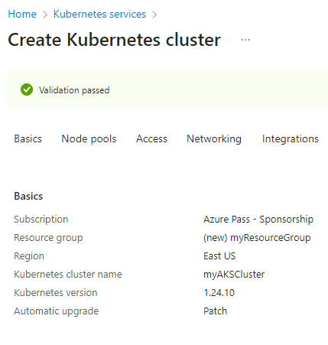

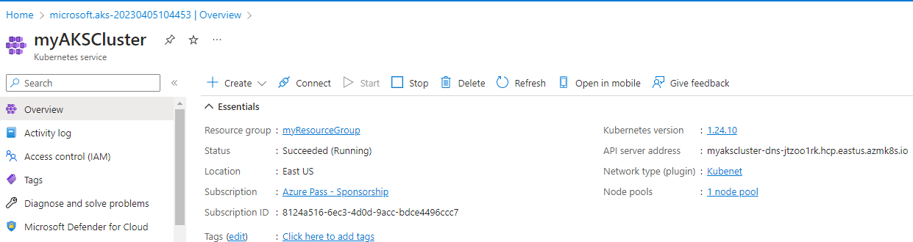

For connecting to the cluster we use the Kubernetes command-line client, [kubectl](https://kubernetes.io/docs/reference/kubectl/).  kubectl is already installed if we use Azure Cloud Shell. The following command downloads credentials and configures the Kubernetes CLI to use them:



To verify the connection to the cluster we are using kubectl get to return a list of the cluster nodes and the output shows the single node created in the previous steps:

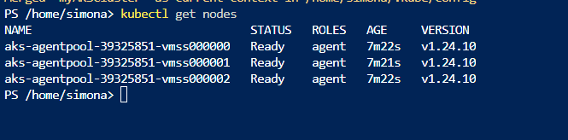

**2.** Check how many pods run under the default namespace. Run kubectl get pods.

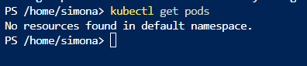  
**3.** You should not see any pod under the default namespace. Now check all namespaces. Run kubectl get pods–all-namespace. or just - A at the end

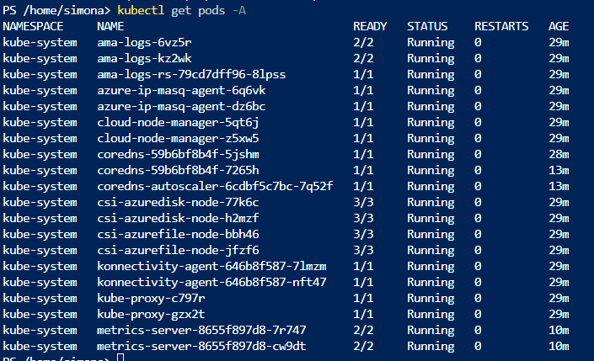  
**4.** How many pods do you see? Who deployed these pods? Why are they deployed?

There are 20 pods that are automatically created. They are deployed by Azure Kubernetes Services and they are needed in order the cluster to function properly

5. Now deploy you first pod using the imperative approach. Run kubectl run nginx --image=nginx.



6. Validate if the pods has been created. What is the status of your pod?

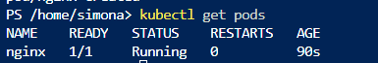

We can see that the status is Running  
7. Check the logs coming out of your pod. Run kubectl logs nginx.

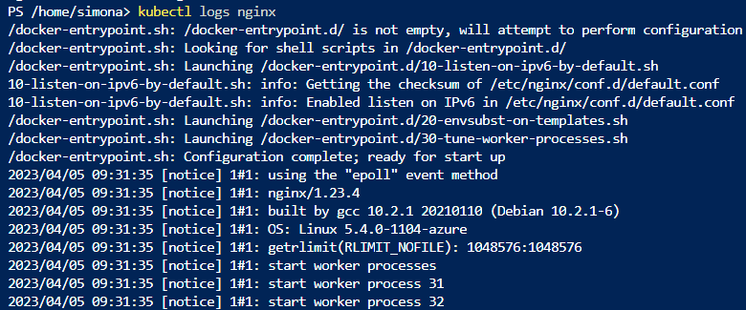  
8. Run following command to check current resource consumption of your pod: kubectl top pod nginx.



9. Check on which Node your pods has been scheduled. Run kubectl get pods –o wide.



10. Try to find the same information but this time running kubectl describe pod nginx.

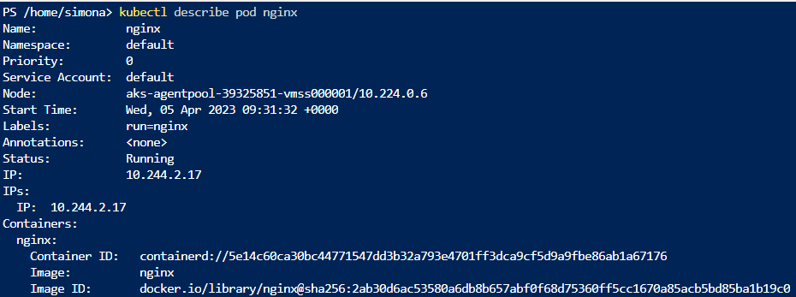with this command we can see some additional informations for the pod

11. Delete your pod using kubectl delete pod nginx.

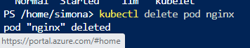

12. Let’s find the image used on one of the coredns pods under the kube-system namespace.

Here are the coredns pods:



13. Once again list all pods under all namespaces.

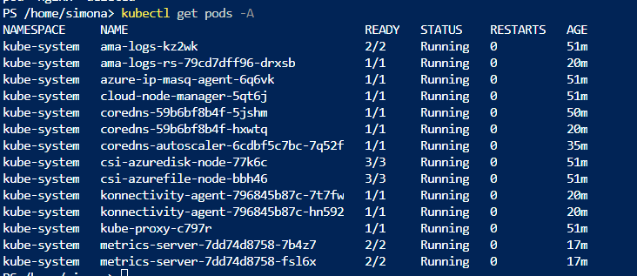  
14. Note one of the coredns pods. Now run kubectl describe pod <coredns-name> -n kube-system. Replace the <coredns-name> place holder with noted name.

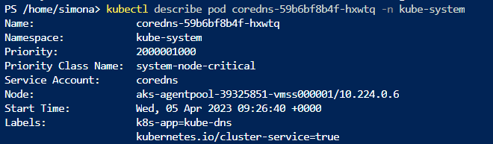  
15. Inspect the output and locate the image information.

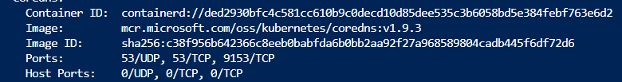  
16. Now let us check the logs of the metrics-server pod. Run the same command as in step 7 but don’t forget to add the namespace in which this pod is created.

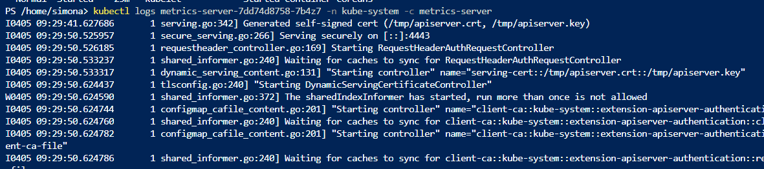

-nflag is used to specify the namespace of the pod

-c flagis used to specify the container name

Practice2: Working with pod manifest files

1. First we need to create a file called redis.yaml with the following content:  
apiVersion: v11kind: podmetadata:name: static-weblabels:role: myrolespecs:containers:- name: redisimage: redis123

So this file is with errors because v11 is not a valid API version. The correct API version for creating Pods is v1, specs should be spec  
2. Try to deploy the pod defined in redis.yaml. Run kubectl create –f redis.yaml.

3. You will receive errors on your screen. Your next task will be to correct the syntax of the code you just  
copied. You can use the online Kubernetes documentation or you can search the internet in general.

The correct API version for creating Pods is v1, specs should be spec, p in pod should be capital  
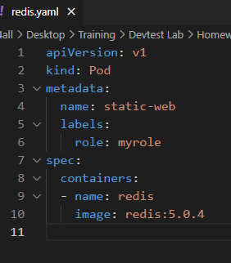

4. When you solve all the syntax errors your pod should be deployed but is it running? What is the status of your pod?



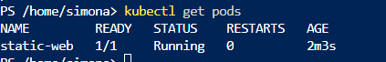

5. Check the events associated with this pod. Run the kubectl describe pod static-web command. What are the events showing? Why your pod is not running?

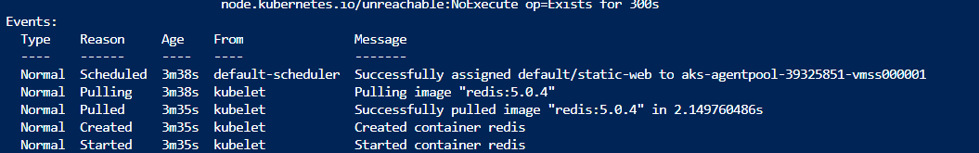

In the previous steps I have found an image and is running correctly

6. Find the correct image (check the Docker hub page) and correct it in the manifest.

In the previous steps I have found an image and is running correctly

7. Locate the image information and put the correct image name. Redeploy the pod (fist run kubectl deletepod static-web to delete the pod, then run kubectl create once again).

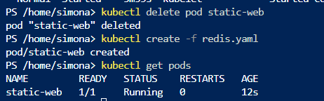

8. Check the status of your pod. It should be running now.

Yes, it is running, we can see that in step 7

9. Now you can delete the pod. Try to delete it using the kubectl delete –f redis.yaml.

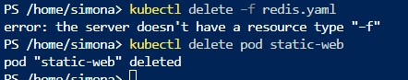

10. Your next task is to create and test nginx pod definition. Your definition should use the nginx official image, should use label named app with value frontend and should publish port 80. Make sure you complete this task because we will use this template in our next Labs. Your nginx pod should be running without any issues.

The created file that is uploaded:

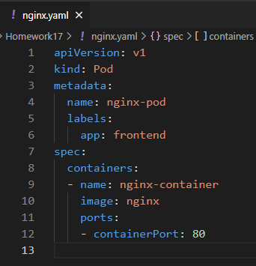

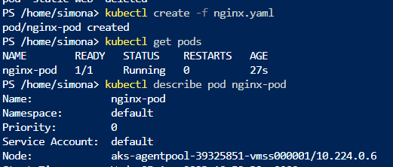

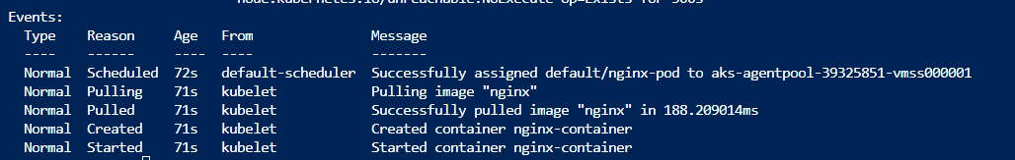

11. Final task of this practice will be to define pod definition with following details:  
- Image=memcached  
- Port= 11211  
- Label app=web  
- CPU request=0.35 cores  
- RAM request=0.15 GB  
- CPU limit=0.5 cores  
- Ram limit=0.25 GB  
- Restart policy=Never

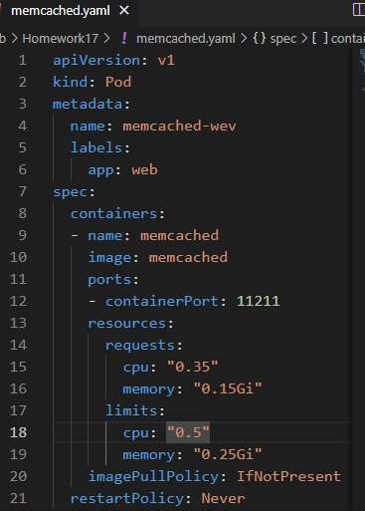

12. Don’t forget to try your pod definition.

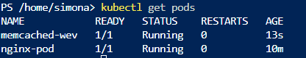

**Practice3: Multi-container pods**

1. Once finished you can try to create multi-container pod definition. Your multi-container pod should use redis and nginx containers with port 6379 and 80 published respectively. Label name should be app with value web.

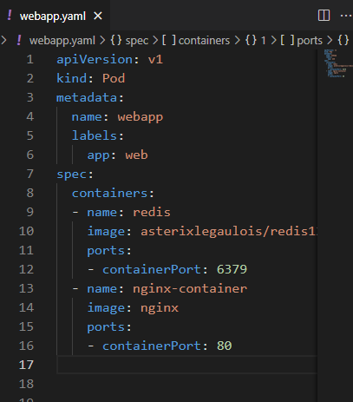

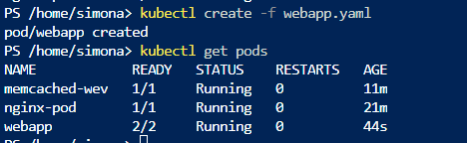

2. Note that in reality there is no sense to put the redis and nginx under the same pod but it can be done for the purpose of learning.

3. Deploy your multi-container pod. It should have running status. What is written under Ready column when you kubectl get the pods? Why your pod displays different values for ready?



In this pod we have two containers so it shows 2/2

4. Kubectl describe you new pod, and locate the containers section. How many containers are listed?

*kubectl describe pod webapp*

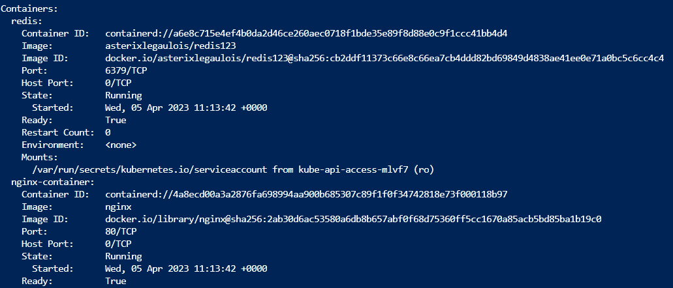2 containers are listed

5. Delete all the pods under the default namespace.

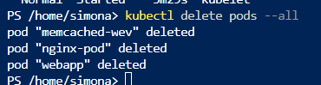

6. Don’t delete any of the manifest files you have created so far.

**Practice4: Probes**

1. First we will create and test liveness probe with exec test. Create a file named probes_exec.yaml with following content: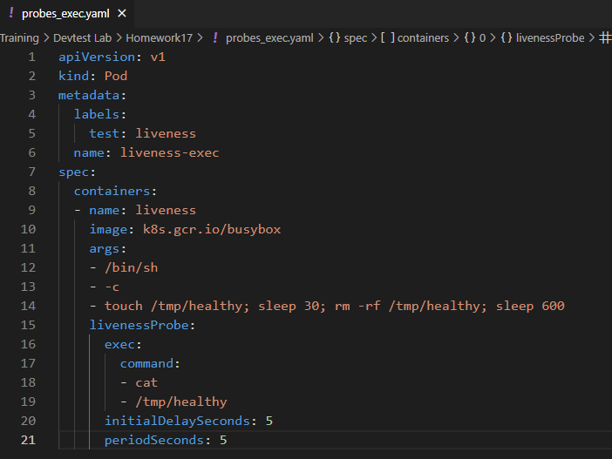

2. Examine the containers args commands especially the line that start with touch. This bash pipeline will help us to test the liveness probes.

A file named /tmp/healthy is created,then sleeps for 30seconds, removes the file and sleeps for 600 seconds.

3. Run **kubectl create –f probes_exec.yaml**.



4. Run **kubectl describe pod liveness-exec** immediately after you deploy the pod. The output should indicate that no liveness probes have failed yet.

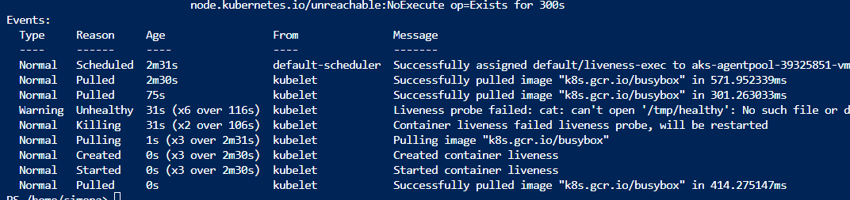

5. After 35 seconds, view the Pod events again. Run **kubectl describe pod liveness-exec.**6. At the bottom of the output, there should be a messages indicating that the liveness probes have failed and the containers have been killed and recreated.

  
7. Wait another 30 seconds, and verify that the container has been restarted. Run **kubectl get pod livenessexec.**

8. The output should show that RESTARTS has been incremented.

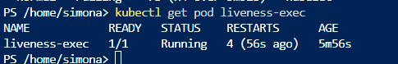

9. We will continue with HTTP probe. Create file named probes_http.yaml with following content:

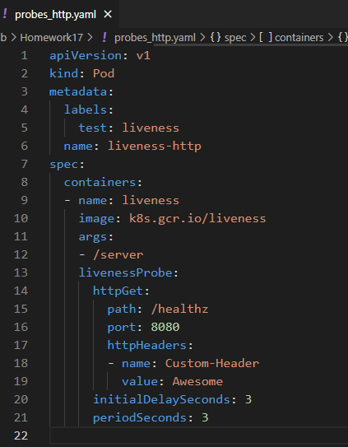

10. Just for your info, /healtz handler has following function implemented:

http.HandleFunc("/healthz", **func**(w http.ResponseWriter, r *http.Request) {  
duration := time.Now().Sub(started)  
**if** duration.Seconds() > 10 {  
w.WriteHeader(500)  
w.Write([]byte(fmt.Sprintf("error: %v", duration.Seconds())))  
} **else** {  
w.WriteHeader(200)  
w.Write([]byte("ok"))  
}  
})

11. For the first 10 seconds that the container is alive, the /healthz handler returns a status of 200. After that, the handler returns a status of 500.  
12. Run **kubectl create –f probes_http.yaml.**13. Immediately run (you only have 10 secs to run this command) **kubectl describe pod liveness-http.**14. Your pod should be live and running.

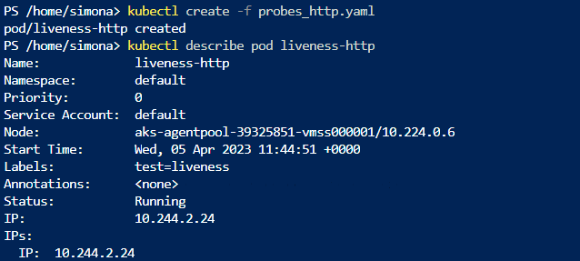

15. After 10 seconds, view Pod events to verify that liveness probes have failed and the container has been restarted. Run again **kubectl describe pod liveness-http.**

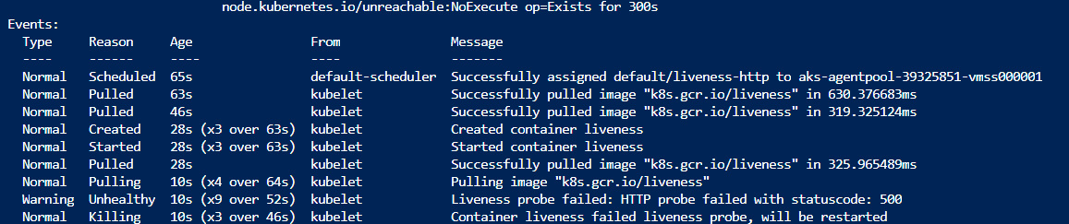16. You should see the same output as in step 7. Kubelet will reboot he container.  
17. We continue with TCP probes. Create file named probes_tcp.yaml with following content:

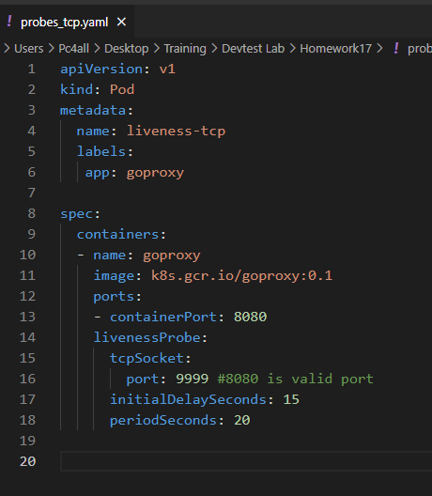

18. Run **kubectl create –f probes_tcp.yaml.**19. Immediately run (you only have 10 secs to run this command) **kubectl describe pod liveness-tcp.**20. Your pod should be live and running.

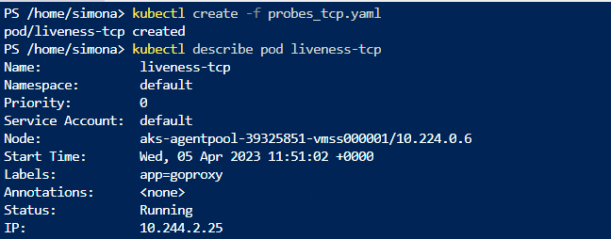  
21. After 10 seconds, view Pod events to verify that liveness probes have failed and the container has been restarted. Run again **kubectl describe pod liveness-tcp.**22. You should see the same output as in step 7 and 16. Kubelet will reboot he container.

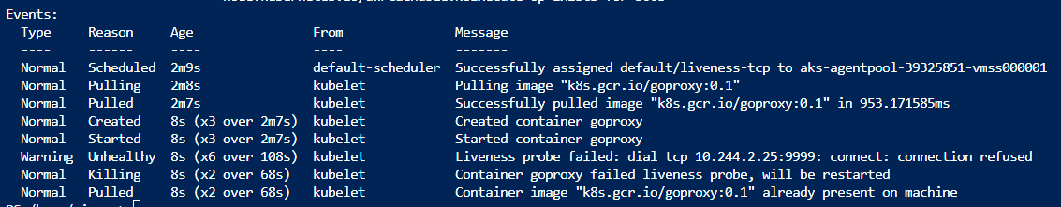  
23. Our last job will be to define one readiness probe using HTTP test.  
24. Create file named readiness_http.yaml with following content:

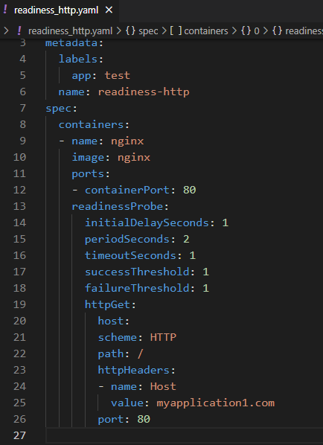

25. Run **kubectl create –f readiness_http.yaml**.  
26. Run **kubectl get pods –A** to see the status of your pod.  
27. Pods and their status and ready states will be displayed; our pod should be in running state.

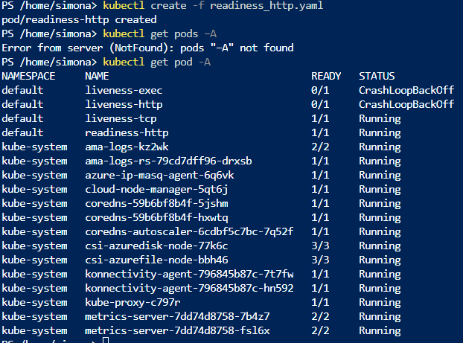  
28. Run **kubectl describe pod readiness-http**. Examine the events for this pod. Everything should be OK.

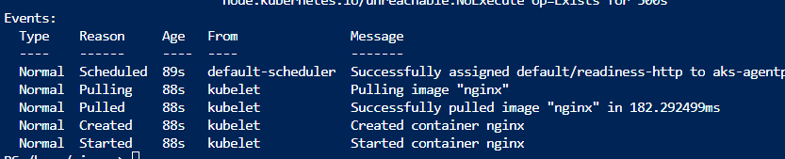  
29. Now delete the pod and edit the readiness_http.yaml so that the port parameter has 81 value.



Here is the changed port with number 81:

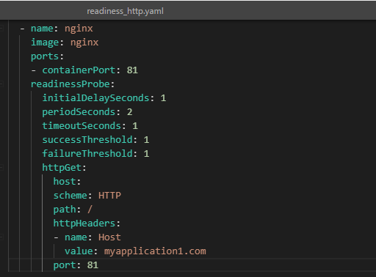

30. Run again **kubectl create –f readiness_http.yaml.**31. Run **kubectl get pods –A** to see the status of your pod. You should see that the pod is running but it is not in ready state.

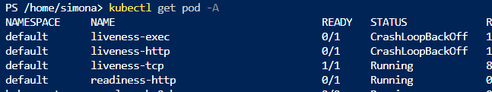  
32. Describe the pod. Run **kubectl describe pod readiness-http.**33. From the events we can see that readiness probe failed due to the connection being refused therefore pod will not receive any traffic.

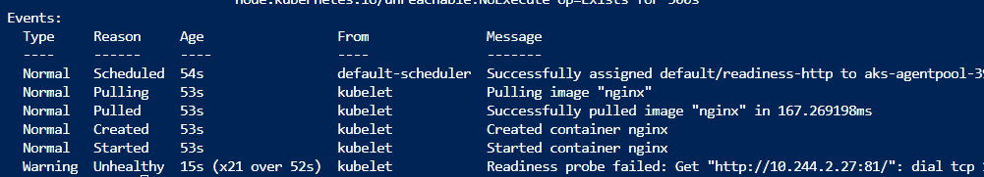  
34. Delete all pods under the default namespace.

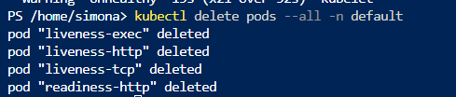  
35. Don’t delete any manifest files created so far.